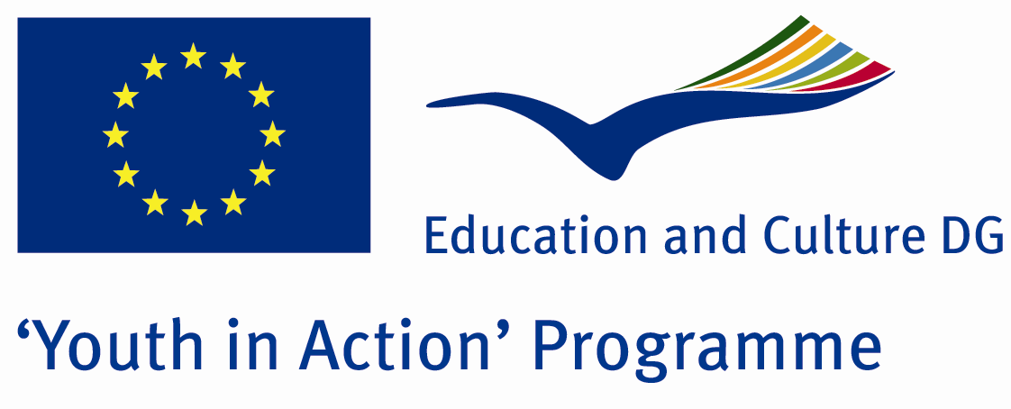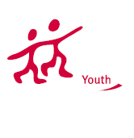

Gold shot 
ACTION 4.3 – Training And Networking

20-26th September, 2011

Mugla, TURKEY

ACTION 4.3 – Training And Networking

Please contact directly to;
adventurerpeacepigeons@gmail.com

Project Summary;

According to United Nations reports, there are over 200 millions people who are using drugs in thw world and it is getting more %8 percent of it every year.Most of them are between 13- 30 ages. Every year, thousands people are dieing because of drugs..and The World of Drugs is bigger than many countries.Drugger youngsters have short and fake lives.but they dont know this and one day they loose their life in a hole…It is so dangerous for our future life and the world…We are living in a global world anymore…So this problem is all of us…For this aim, we want to make a Project about drugs…its damages?how can we save us and our families, friends agains th drugs?

Project Title; Gold shot

Date and Venue ; 20-26th September, 2011, Mugla, Turkey .

Target Group ; Municipalities, City Councils and Non-Governmental organizations,
youth groups,culture and art groups,e.t.c

Participants ; 5 people from each country (over 18 -25 ). Totally 8 countries.

Conditions ; Accommodation, board and programme costs will be financed through European Commission Youth in Action Programme ….Travel costs will be reimbursed in 70% (APEX Tarrifs). Organizations from all 27 EU member countries plus Liechtenstein , Norway and Iceland are eligible to take part.

Working language: English

Organizer; Adventurer Peace Pigeons

How to apply: If you are interested, please send your Part III forms to
by e-mail please. Scan Part3 format is enough for application. (Fulfilled Part III which you can find in the attachment, of course signed and stamped) ..

Next step 2;
Original send via regular post to this address please:

Ertan DERİN
Fevzi Çakmak Mahallesi Tuncer Sokak No:6 PENDİK/İSTANBUL/TÜRKİYE
e-mail : adventurerpeacepigeons@gmail.com
Mobile : 0090 542 393 93 90

If you have any questions you may contact with: adventurerpeacepigeons@gmail.com
Deadline: 15th May 2011

For Further information:
Contact Person
Ertan DERİN

Fevzi Çakmak Mahallesi Tuncer Sokak No:6 PENDİK/İSTANBUL/TÜRKİYE
e-mail : adventurerpeacepigeons@gmail.com
Mobile : 0090 542 393 93 90

